

Department of Electronics and Communication Engineering ECA47 Principles of Digital System Design

LAB MANUAL

This page is intentionally left blank

INDEX

Ex.No. | Date | Title | Marks | Staff Sign.
1 |  | Verification of Boolean Theorems Using Digital Logic Gates
2. |  | Verification of De Morgan’s Law Using Basic Logic Gates
3. |  | Implementation of Binary To Gray Code Converter
4. |  | Implementation of Binary Adders and Subtractors
5. |  | Multiplexer And Demultiplexer
6. |  | Design of Combinational Logic Circuits
7. |  | Implementation of Flip Flop Using Logic Gates  7.1 SR Flip Flop  7.2 D Flip Flop  7.3 JK Flip Flop
8. |  | Implementation of Arithmetic Operations Using 8051 Microcontroller
9. |  | Interfacing 7 Segment Display With 8051 Microcontroller
10. |  | Design, Implementation, and Simulation of Combinational Circuits using Verilog HDL
11. |  | Design, Implementation, and Simulation of Shift Register Using Verilog HDL
12. |  | Design, Implementation, and Simulation of Mod 5 Counter Using Verilog HDL

Ex.No.-1 VERIFICATION OF BOOLEAN THEOREMS USING DIGITAL LOGIC GATES
Date:
AIM:
To Implement and verify the following Boolean theorems using logic gates and the Digital Trainer Kit.
- Implement the commutative theorem (A + B = B + A) using logic gates.
- Implement the Absorption Law A+A’B=A+B
- Implement the associative theorem (A + B + C) = (A + B) + C = A + (B + C)) using logic gates

APPARATUS REQUIRED:

SL. NO. | COMPONENT | SPECIFICATION | QTY.
1. | AND GATE | IC 7408 | 1
2. | OR GATE | IC 7432 | 1
3. | NOT GATE | IC 7404 | 1
4. | IC TRAINER KIT | - | 1
5. | CONNECTING WIRES | - | As required

THEORY:

BASIC BOOLEAN LAWS

Commutative Law
The binary operator OR is said to be commutative if,
A+B = B+A

Absorption Law
A+A’B=A+B

Associative Law
The binary operator OR is said to be associative if,
A+(B+C) = (A+B)+C

COMMUTATIVE

TRUTH TABLE
I/P |  | LHS (O/P) | RHS (O/P)
A | B | A+B | B+A
0 | 0 | 0 | 0
0 | 1 | 1 | 1
1 | 0 | 1 | 1
1 | 1 | 1 | 1

LOGIC DIAGRAM
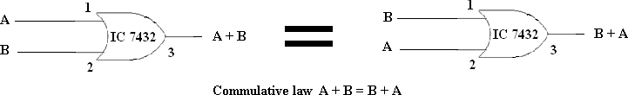

ABSORPTION

TRUTH TABLE

I/P |  |  |  | LHS (O/P) | RHS(O/P)
A | B | A' | A'B | A + (A'B) | A + B
0 | 0 | 1 | 0 | 0 | 0
0 | 1 | 1 | 1 | 1 | 1
1 | 0 | 0 | 0 | 1 | 1
1 | 1 | 0 | 0 | 1 | 1

LOGIC DIAGRAM
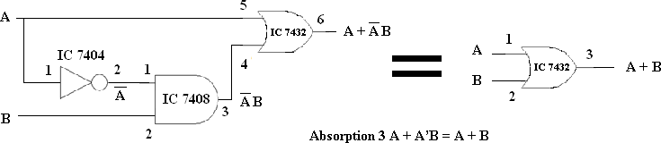

TRUTH TABLE
I/P |  |  |  | LHS (O/P) |  | RHS (O/P)
A | B | C | B+C | A + (B+C) | A + B | (A + B ) + C
0 | 0 | 0 | 0 | 0 | 0 | 0
0 | 0 | 1 | 1 | 1 | 0 | 1
0 | 1 | 0 | 1 | 1 | 1 | 1
0 | 1 | 1 | 1 | 1 | 1 | 1
1 | 0 | 0 | 0 | 1 | 1 | 1
1 | 0 | 1 | 1 | 1 | 1 | 1
1 | 1 | 0 | 1 | 1 | 1 | 1
1 | 1 | 1 | 1 | 1 | 1 | 1

LOGIC DIAGRAM
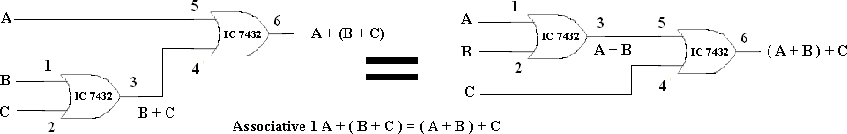

PROCEDURE:

- Obtain the required IC along with the Digital trainer kit.
- Connect zero volts to GND pin and +5 volts to Vcc .
- Apply the inputs to the respective input pins.
- Verify the output with the truth table.

RESULT:
Thus the above stated Boolean laws are verified.

Ex.No.-2 VERIFICATION OF DE MORGAN’S LAW USING BASIC LOGIC GATES
Date:
AIM:
To verify De Morgan's law using basic logic gates and construct the associated truth tables.

APPARATUS REQUIRED

SL. NO. | COMPONENT | SPECIFICATION | QTY.
1. | AND GATE | IC 7408 | 1
2. | OR GATE | IC 7432 | 1
3. | NOT GATE | IC 7404 | 1
4. | IC TRAINER KIT | - | 1
5. | CONNECTING WIRES | - | As required

THEORY

De-Morgan’s theorem:
- The complement of the sum is equal to the product of the individual complements.
(A+B)’=A’.B’
- The complement of the product is equal to the sum of the individual complements.
(A.B)’=A’+B’

TRUTH TABLE

I/P |  |  | LHS (O/P) |  |  | RHS (O/P)
A | B | (A + B) | (A + B)' | A' | B' | A'.B'
0 | 0 | 0 | 1 | 1 | 1 | 1
0 | 1 | 1 | 0 | 1 | 0 | 0
1 | 0 | 1 | 0 | 0 | 1 | 0
1 | 1 | 1 | 0 | 0 | 0 | 0

LOGIC DIAGRAM
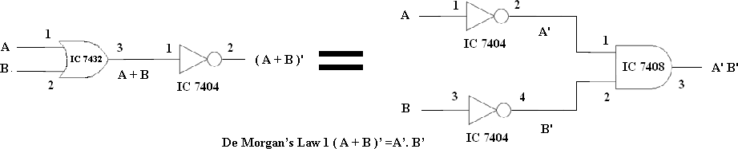

TRUTH TABLE

I/P |  |  | LHS (O/P) |  |  | RHS (O/P)
A | B | (AB) | (AB)' | A' | B' | A' + B'
0 | 0 | 0 | 1 | 1 | 1 | 1
0 | 1 | 0 | 1 | 1 | 0 | 1
1 | 0 | 0 | 1 | 0 | 1 | 1
1 | 1 | 1 | 0 | 0 | 0 | 0

LOGIC DIAGRAM
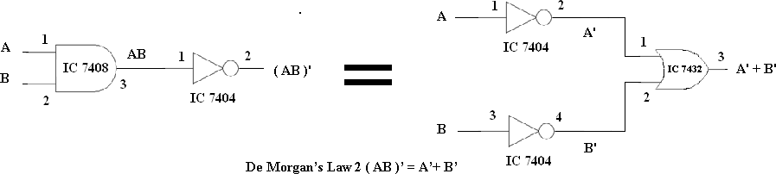

PROCEDURE:
  - Obtain the required IC along with the Digital trainer kit.
  - Connect zero volts to GND pin and +5 volts to Vcc .
  - Apply the inputs to the respective input pins.
  - Verify the output with the truth table.

RESULT:
Thus the above stated Demorgan’s Theorem is verified .

Ex.No.-3 IMPLEMENTATION OF BINARY TO GRAY CODE CONVERTER

Date:

AIM:
To design and implement a 4-bit Binary to Gray Code Converter using ICs on a Digital trainer kit and verify its operation experimentally.

APPARATUS REQUIRED:

SL.NO. | COMPONENT | SPECIFICATION | QTY
1. | X-OR GATE | IC 7486 | 1
2. | NOT GATE | IC 7404 | 1
3. | IC TRAINER KIT | - | 1
4. | CONNECTING WIRES | - | 35
5. | BREAD BOARD |  | 1

PROCEDURE:
- Obtain the required IC and Digital Trainer Kit.
- Connect +5 V to VCC and 0 V to GND.
- Make the circuit connections as per the circuit diagram.
- Apply the binary inputs to the input pins.
- Observe the Gray code outputs.
- Verify the outputs using the truth table.

TRUTH TABLE:
Binary Input |  |  |  | Gray Code Output
B3 | B2 | B1 | B0 | G3 | G2 | G1 | G0
0 | 0 | 0 | 0 | 0 | 0 | 0 | 0
0 | 0 | 0 | 1 | 0 | 0 | 0 | 1
0 | 0 | 1 | 0 | 0 | 0 | 1 | 1
0 | 0 | 1 | 1 | 0 | 0 | 1 | 0
0 | 1 | 0 | 0 | 0 | 1 | 1 | 0
0 | 1 | 0 | 1 | 0 | 1 | 1 | 1
0 | 1 | 1 | 0 | 0 | 1 | 0 | 1
0 | 1 | 1 | 1 | 0 | 1 | 0 | 0
1 | 0 | 0 | 0 | 1 | 1 | 0 | 0
1 | 0 | 0 | 1 | 1 | 1 | 0 | 1
1 | 0 | 1 | 0 | 1 | 1 | 1 | 1
1 | 0 | 1 | 1 | 1 | 1 | 1 | 0
1 | 1 | 0 | 0 | 1 | 0 | 1 | 0
1 | 1 | 0 | 1 | 1 | 0 | 1 | 1
1 | 1 | 1 | 0 | 1 | 0 | 0 | 1
1 | 1 | 1 | 1 | 1 | 0 | 0 | 0

K-Map for G3 K-Map for G2
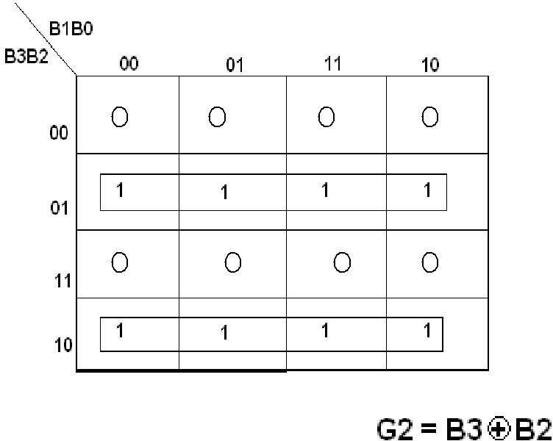
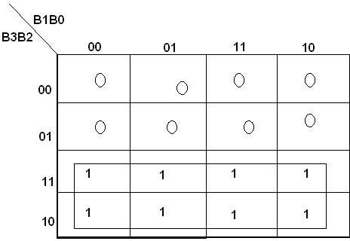
G3 = B3
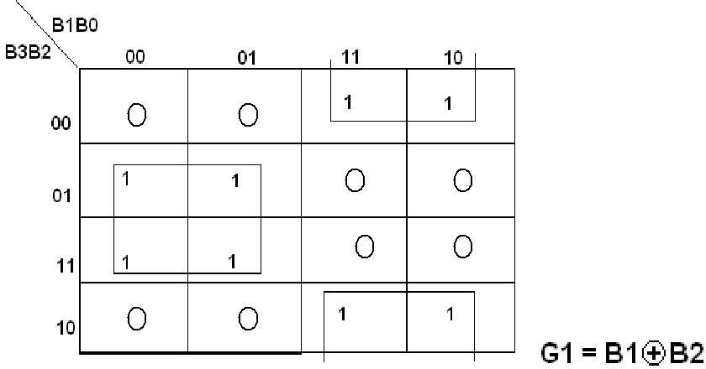
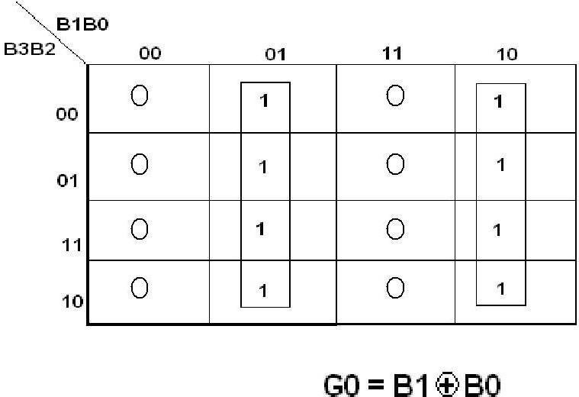

K-Map for G1 K-Map for G0

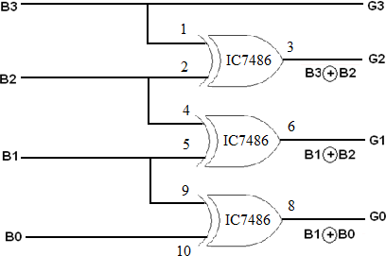
LOGIC DIAGRAM:

RESULT:
Thus the above stated Binary to Gray code Converter is implemented.
Ex.No.-4 IMPLEMENTATION OF BINARY ADDERS AND SUBTRACTORS
Date:
AIM
To design a half adder and a full subtractor circuit on the Digital Trainer Kit.

APPARATUS REQUIRED:

Sl.No. | COMPONENT | SPECIFICATION | QTY.
1. | AND GATE | IC 7408 | 1
2. | X-OR GATE | IC 7486 | 1
3. | NOT GATE | IC 7404 | 1
4. | OR GATE | IC 7432 | 1
5. | IC TRAINER KIT | - | 1
6. | CONNECTING WIRES | - | As required

HALF ADDER:

TRUTH TABLE:
A | B | SUM | CARRY
0 | 0 | 0 | 0
0 | 1 | 1 | 0
1 | 0 | 1 | 0
1 | 1 | 0 | 1

Sum = A’B+ AB’= A⊕B
Carry = A . B

PROCEDURE:
- Connections are given as per the logic diagram
- Input are given to the circuit making high ‘1’ i.e. +5 or Vcc Supply to the 14th pin and for low ‘0’ i.e. GND to the 7th pin of the Gate IC
- Depending upon the truth table, if the LED Glow it represents 1 and else it represents ‘0’
- Verify the truth table as given

LOGIC DIAGRAM FOR HALF ADDER:
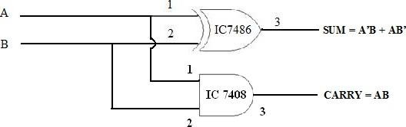

FULL SUBRACTOR: TRUTH TABLE:
A | B | C | DIFFERENCE | BORROW
0 | 0 | 0 | 0 | 0
0 | 0 | 1 | 1 | 1
0 | 1 | 0 | 1 | 1
0 | 1 | 1 | 0 | 1
1 | 0 | 0 | 1 | 0
1 | 0 | 1 | 0 | 0
1 | 1 | 0 | 0 | 0
1 | 1 | 1 | 1 | 1
Difference = A’B’C +A’BC’ + AB’C’ + ABC
=A’(B’C+BC’)+A(B’C’+BC)
=A’(B⊕C)+ A (B⊕C)’
=A⊕B⊕C

Borrow = A’B’C +A’BC’ + A’BC + ABC
= C(A’B’+ AB)+ A’B (C+C’)
= C(A⊕B)’+ A’B

LOGIC DIAGRAM FOR FULL SUBTRACTOR:
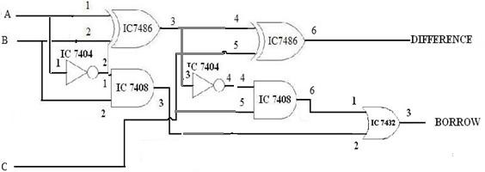

RESULT:
Thus, the half adder and full subtractor were designed and verified successfully using Truth table.

Ex.No 5. MULTIPLEXER AND DEMULTIPLEXER

Date:

AIM:

To implement the 2:1 multiplexer and 1:2 Demultiplexer circuit on the Digital Trainer Kit.

APPARATUS REQUIRED:
SL.NO. | COMPONENT | SPECIFICATION | QTY.
1. | AND GATE | IC 7408 | 1
2. | OR GATE | IC 7432 | 1
3. | NOT GATE | IC 7404 | 1
2. | IC TRAINER KIT | - | 1
3. | PATCH CORDS | - | 32

PROCEDURE:
  - Connections are given as per circuit diagram.
  - Logical inputs are given as per circuit diagram.
  - Observe the output and verify the truth table.

LOGIC DIAGRAM OF 2:1 MULTIPLEXER
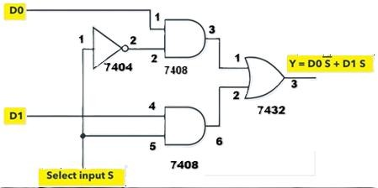

TRUTH TABLE:

Select Input S | Y = OUTPUT
0 | D0
1 | D1

LOGIC DIAGRAM OF 1:2 DEMULTIPLEXER
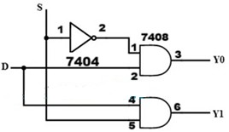

TRUTH TABLE:

Input S | Outputs
 | Y0 | Y1
0 | D | 0
1 | 0 | D

RESULT:
Thus the multiplexer and demultiplexer using logic gates are designed and implemented

